Workshop – Using Short Term Teams to Initiate and Sustain Integrated Community Health and Development Programs
Two-Time Winner Of “LONGEST WORKSHOP TITLE” Award (just kidding)

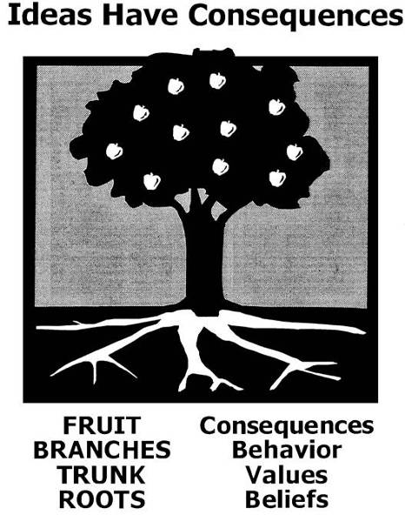
What could small groups of people from the USA do during week-long trips to help invigorate, inform, and empower the local people for months, years, and even generations? This workshop will present some field examples of this happening, clarify some key factors for this style of Short-Term Missions (STM) to be successful, and generate your input on how to measure a truly successful STM trip. Come prepared to participate, and leave motivated to change. (repeat of last year)

EXAMPLES:
- school screening - Ghana
Key Factors #3a
- electric water well pump – Pacific Rim
- house construction – 1Mission
- village visit – World Bible League - Philippines
- VBS – Rochester Christian Church (in Haiti)

KEY FACTORS:
- identifying, training, and respecting all the co-workers
Fruit >
Branches >
Trunk >
Roots >
  - goers-guests
  - hosts-receivers
  - senders
    - organizations (relief based vs. development based)
    - churches (examine attitudes and methods for local missions vs. foreign missions)
  - supporters (those who support the work through prayer, money, encouragement, etc.)
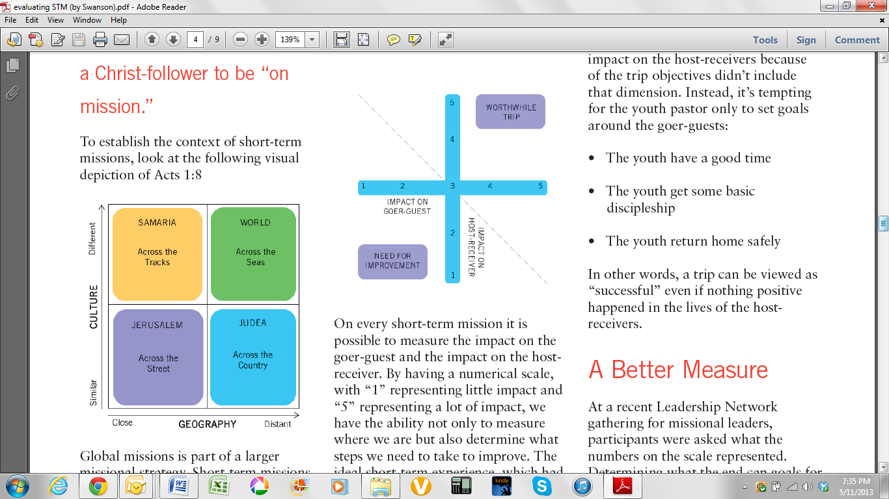
- do what’s best (river crossing video)
  - two feel good
Key Factors #1cii
and
Measuring True Success
#3
  - together
Which did you like best as a model for missions?
- Specifically, what did you like? *
- What did you not like about the other? *
- What keeps the best from happening? *
- deal with root issues
Revelations 20:3,7-8
2 Corinthians 4:4
1 Timothy 4:1
Colossians 2:8
  - getting to the real problem
  - Satan’s tactics
  - greater time & effort

MEASURING TRUE SUCCESS
- beneficial to all the co-workers (listed in KF 1a-1d)
- How is it measured and when is evaluation done?
- all four quadrants
EFFORT
D C B A
QUALITY
- D to C to B to A
Key Factors #3c and
MTS #4
Measuring True Success #2
CASE STUDY (over)

Resources:
- Global CHE Network (River Crossing Video & discussion guide) www.CHEnetwork.org/videos.php
- “Operating Responsible Short-Term Healthcare Missions” free PDF download (plus more) https://sites.google.com/a/gwmail.gwu.edu/globalhealthmissions/Home/operating-responsible-short-term-healthcare-missions
- about building a healthcare program for developing countries - http://www.hepfdc.info/
- Increasing the Effectiveness of Short-Term Missions by Eric Swanson http://leadnet.org/blog/post/increasing_the_effectiveness_of_short-term_missions
Case Study: Short Term Medical Trips with Long Term Impact

A medical team from the San Francisco Bay area had taken two trips to Ethiopia to provide free medical clinics in a village in an underserved area. They were not feeling good about what they were doing. Questions were emerging in their minds:

- Are our clinics recycling centers? Are we treating people and sending them back to their communities to drink the same water that made them sick?
- What percentage of the illnesses we are treating might be prevented through clean water, sanitation, hygiene, nutrition, and health promotion?
- What are we teaching the people about health? Are we ignoring the role the people themselves might play in preventing disease?
- Do our trips build the reputation and capacity of local medical professionals to meet the needs of their own people?
- How do the locally trained medical professionals view our trips? Cooperating? Competing?
- Are we introducing medications as the solution to certain problems that are not locally available? Are there medications that are locally available that can be used?
As they talked through these issues, they decided to return to Ethiopia a third time without taking any medications with them. They would deliberately focus on what the people have, not what they lack. They would help people do for themselves instead of doing things for them. Their goals would be:

- To build the reputation and capacity of local medical professionals.
- To raise awareness of what the local people could do to prevent disease, and get them working together to do it.

The first thing they did on this third trip was to meet with the medical professionals in the city near to the village where they were working. They got to know the doctors and nurses, and gained an appreciation for their knowledge, skills, and resources. They worked together with the medical professionals on a plan for a school screening in the elementary school in the village. The short term team would screen the children for medical problems, and document major health concerns. When a child needed immediate medical attention, they would be referred to the local medical professionals. No medications would be made available at the school screening. They knew this would frustrate and cause some anger in those who had come to expect free medicines. But they calculated that the long term impact would be worth the pain.

After the screening, the short term team compiled the data they gathered into a chart that documented the major health concerns and the percentage of children affected. Together with local medical professionals and CHE trainers, they fed back the information to the community at a parents meeting. With guidance from the CHE team, the community identified one illness they would work together to prevent, and made a plan to do it.

This time the short term team went home feeling good about what they had done. They had built the reputation and capacity of the local medical professionals, and left the community with a vision for what they could do to improve the health of their families and community.

