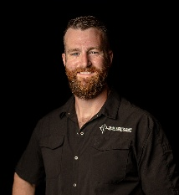 | Owner: Ben Fries, M.S.Ed., B.S.  benfries@friesconsulting.us  (260)403-2924  www.friesconsulting.us  www.thefriesfoundation.org | 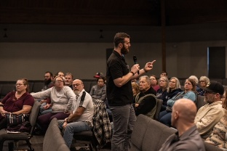 | 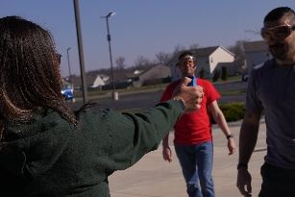
Who We Are
Fries Consulting, LLC is a nationally operating safety and protection training firm specializing in active-threat preparedness, scenario-based response training, and practical defensive education for private sector organizations, houses of worship, schools, and businesses across the United States. Licensed, insured, and experienced coaching.
Founded and led by Ben Fries, a 15-year full-time law enforcement veteran, current SWAT team member, SWAT sniper, SWAT training coordinator, and recipient of multiple lifesaving and valor awards, Fries Consulting was built on real-world experience, solution-focused brief therapy principles, and a commitment to defendable, professional instruction.
What We Do
Deterring an Active Threat
Our flagship course delivers realistic, scenario-based training inside actual facilities.
Participants learn:
- Building safety vulnerabilities
- Decision-making under stress (after coaching skills)
Courses are delivered using structured lesson plans and realistic simulations to expose strengths and vulnerabilities in a safe, controlled environment.
Pepper Gel Certification
We provide certification-based instruction for Sabre Pepper Gel:
- Pepper Gel Certification for civilian use
- Role playing and inert pepper gel deployments for students to practice spray
Advanced CPTED & Facility Assessments
We conduct Advanced Crime Prevention Through Environmental Design (CPTED)-based evaluations and site assessments to identify security gaps and recommend improvements tailored to each facility.
Our Philosophy
We do not use fear-based training.
We use psychology-backed learning principles and realistic simulations to build confidence, clarity, and competence.

