MedicalMissionsMentoring.com
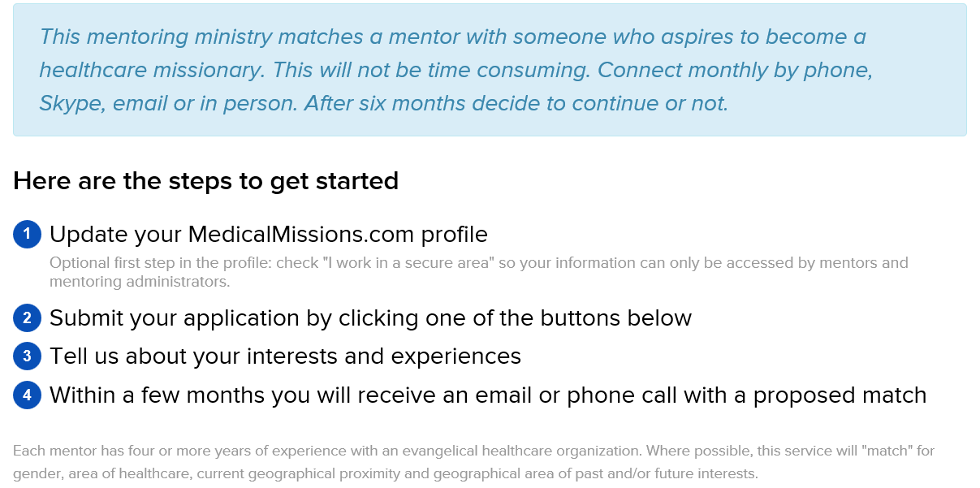

MedicalMissionsMentoring.com

