GLC Weekly
(11 June 2026)

New Fire At The Founding
AUDIOBOOK Available

Thomas W. Jacobson, Founder, Global Life Campaign

Today is my father’s 98th birthday, and a special day to make this announcement because he has been a great support to me in such noble works.

The audiobook version of Fire At The Founding has finally been published and is available at the WestBow Press Bookstore website: WestBow Press Bookstore. The audiobook was a lot of fun to produce. Even though I’m the primary narrator voice, Dr. Steve Holt (my senior pastor) and Pastor Mark Cowart (friend) read their endorsements. The voices for the 25 clergy (from the 1700s) and six other Christian leaders in the book were: seven pastors from my church in Colorado Springs, other men from my church and the weekly Wholehearted Men’s Breakfast (a special shout out to table 12 men whom I lead), my brother Mike, and other friends.
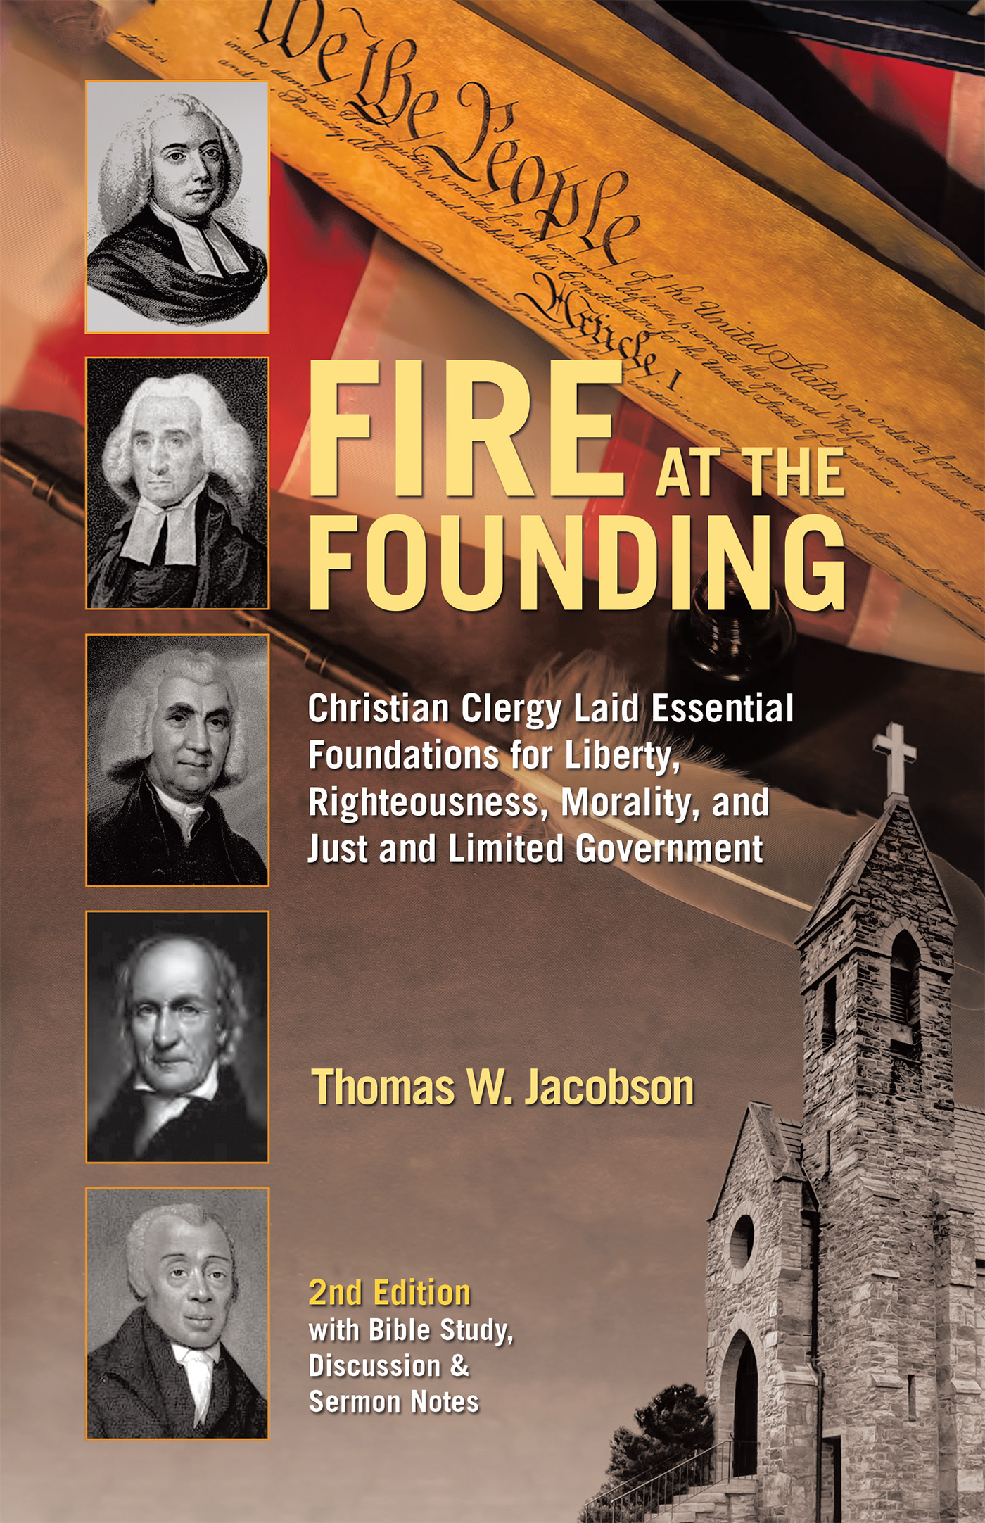
BUY THE AUDIOBOOK: Fire At The Founding: Christian Clergy Laid Essential Foundations for Liberty, Righteousness, Morality, and Just and Limited Government. Available: WestBow Press Bookstore.

BUY THE EBOOK: Fire At The Founding: Christian Clergy Laid Essential Foundations for Liberty, Righteousness, Morality, and Just and Limited Government. USA 250th Anniversary edition. Available through GLC Publications.

BUY THE PRINT BOOK or KINDLE: Fire At The Founding: Christian Clergy Laid Essential Foundations for Liberty, Righteousness, Morality, and Just and Limited Government. USA 250th Anniversary edition. Available through Amazon, Barnes & Noble, etc.

PRAY that the Bible and this book will profoundly impact Christ followers and others in the United States and in many other nations, including by: strengthening each one and the Body of Christ in their faith in GOD, knowledge and trust in His Word, deeper development of a Biblical and Judeo Christian worldview, embolden pastors and Christian leaders to be strong and courageous, and restore the church as “the pillar and support of the truth” (1 Timothy 3:15).

For the LORD, the sacred gift of life, the sacred gift of liberty, and remembrance of the babies,

Thomas W. Jacobson
Founder & Executive Director, Global Life Campaign
TJacobson@GLClife.org ; www.GLCllife.org ; www.GLCPublications.com

The purpose of the Global Life Campaign is to call and equip trustworthy disciples inspired by the Holy Spirit, to be a catalyst movement to establish principles and practices in nations that align with the Word of God and respect human life.

